Reading Academic Vocabulary Comprehensive Word Lists
Reading/Fluency | Reading/Comprehension of Literary Text/Drama |  | Reading/Vocabulary Development |  |  |  |  | Reading/Comprehension of Literary Text/Theme and Genre
expression  fluency  read  text | drama  film  play  playwright  stage direction |  | adage  affix  ambiguous  analogy  antonym/synonym  clarify  derived  determine  dictionary  foreign  glossary  Greek affix  Greek root  idiom  Latin affix  Latin root |  |  | linguistic root  multiple meaning words  pronunciation  root  saying  syllable  thesaurus  understand  unfamiliar  vocabulary  whole  word choice |  | classical  comprehension  culture  describe  distinguish  epic tale  fiction  genre  historical  inference/infer  literary  literature  moral  movement  myth  phenomena  place  theme  time
Reading/Comprehension of Literary Text/Poetry |  |  | Reading/Comprehension of Literary Text/Sensory Language |  | Reading/Comprehension of Text/Independent Reading |  |  | Reading/Comprehension of Literary Text/Fiction
alliteration  analyze  hyperbole  internal rhyme  onomatopoeia  personification  poet  poetry  rhyme scheme  sound effect  BOLD high-frequency word in the TEKS |  |  | author  evaluate  imagery  mood  refrain  sensory language |  | journal  logical order  reading log |  |  | character  climax  conflict  denouement dialect  explain  falling action  foreshadow  forms | motivation  novel  plot  plot development  relationship  rising action  role  turning point
Reading/Comprehension of Literary Text/Literary Nonfiction |  | Reading/Comprehension of Informational Text/Expository Text |  |  |  |  | Reading/Comprehension of Informational Text/Persuasive Text
autobiography  biography  characteristic  diary  literary device  literary language  memoir  nonfiction  structural pattern |  | classification scheme  claims  compare and contrast  different  draw conclusions  logical connection  main idea  meaning  method  opinion  organizational |  | overview  problem-and-solution  proposition-and-support  sequential order  similarities  summarize  summary  supporting detail  synthesize  text feature  verify |  |  | ad hominem  argument  author’s viewpoint  exaggerated  identify  parallelism  policy  rhetorical fallacy  stereotype/ stereotyping  structure  viewpoint
Reading/Comprehension of Informational Text/Culture and History |  | Reading/Comprehension of Informational Text/Procedural Texts |  |  |  |  | Reading/Media Literacy
author’s purpose  contemporary  implicit/implied  BOLD high-frequency word in the TEKS |  | diagram  factual  illustration  interpret  map  perform  problem  procedural  procedure  quantitative (information)  solve  table  task  timeline |  |  |  |  | commercial  critique  digital  documentary  explicit  formality/informality  image  influence  media  news  recognize  technique  tone  venue

Reading/Fluency
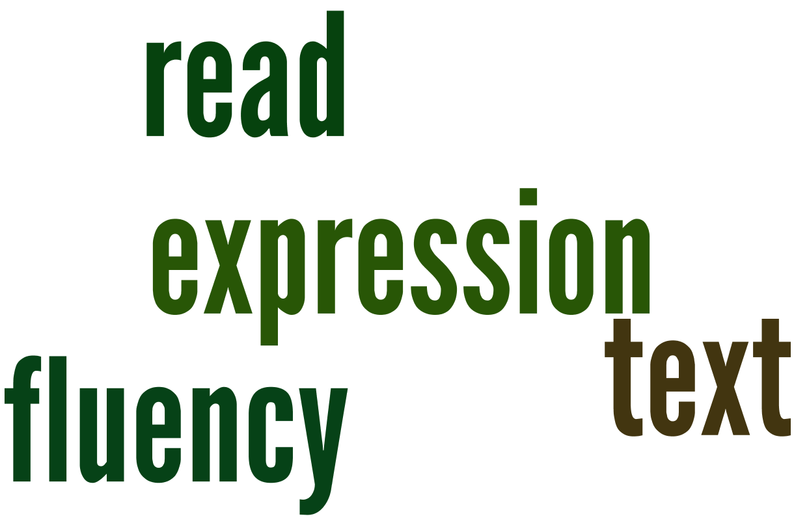
Reading/Comprehension of Literary Text/Drama
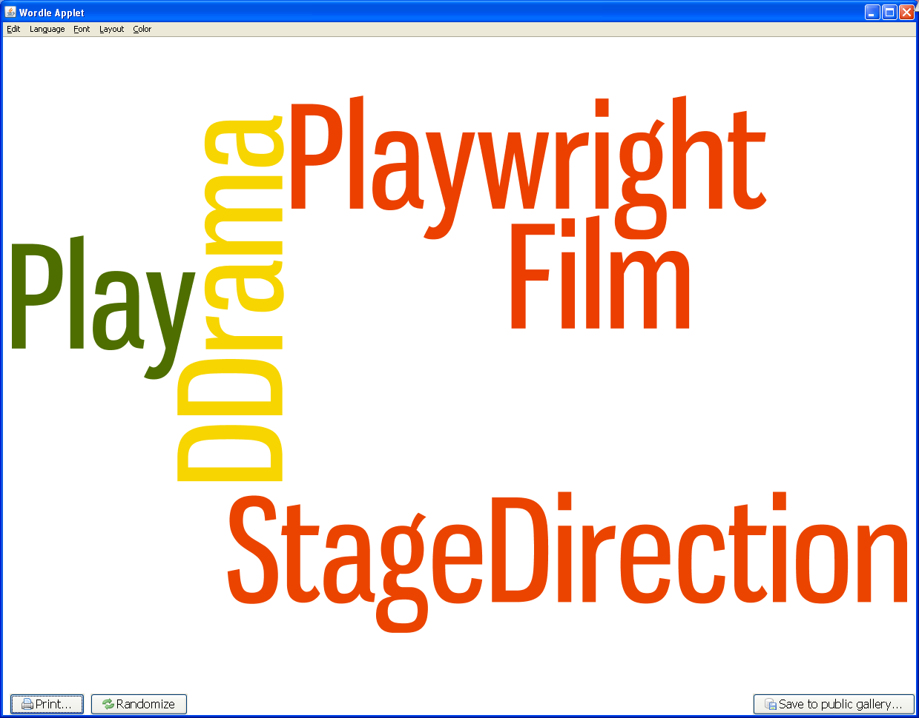
Reading/Vocabulary Development
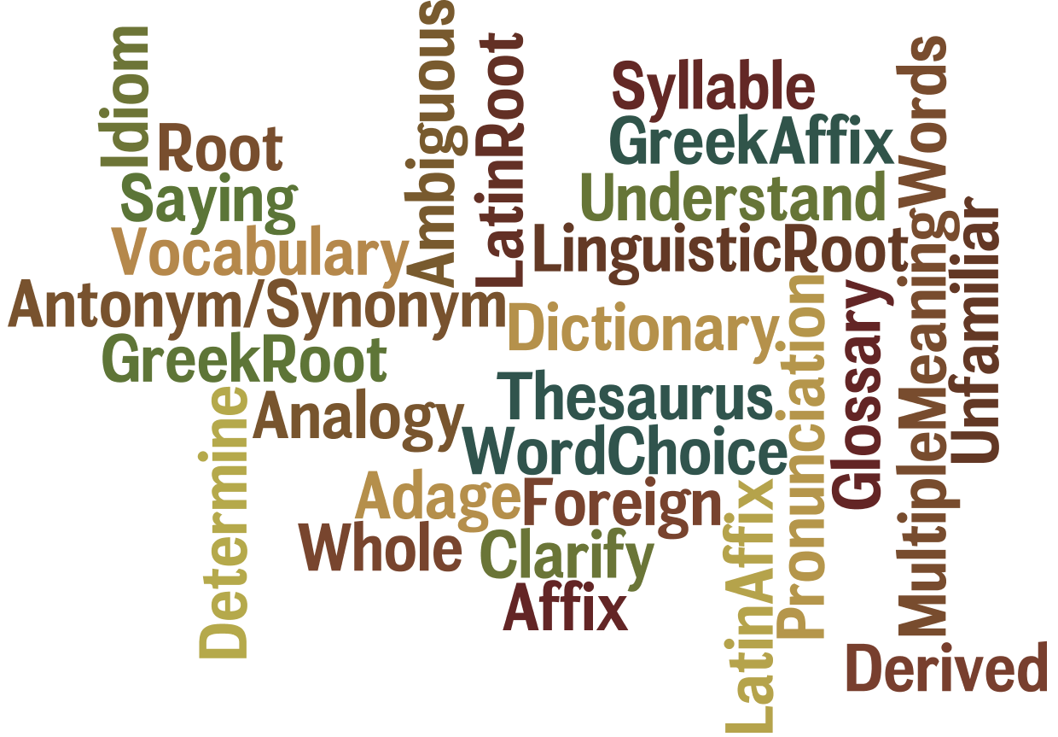

Reading/Comprehension of Literary Text/Theme and Genre
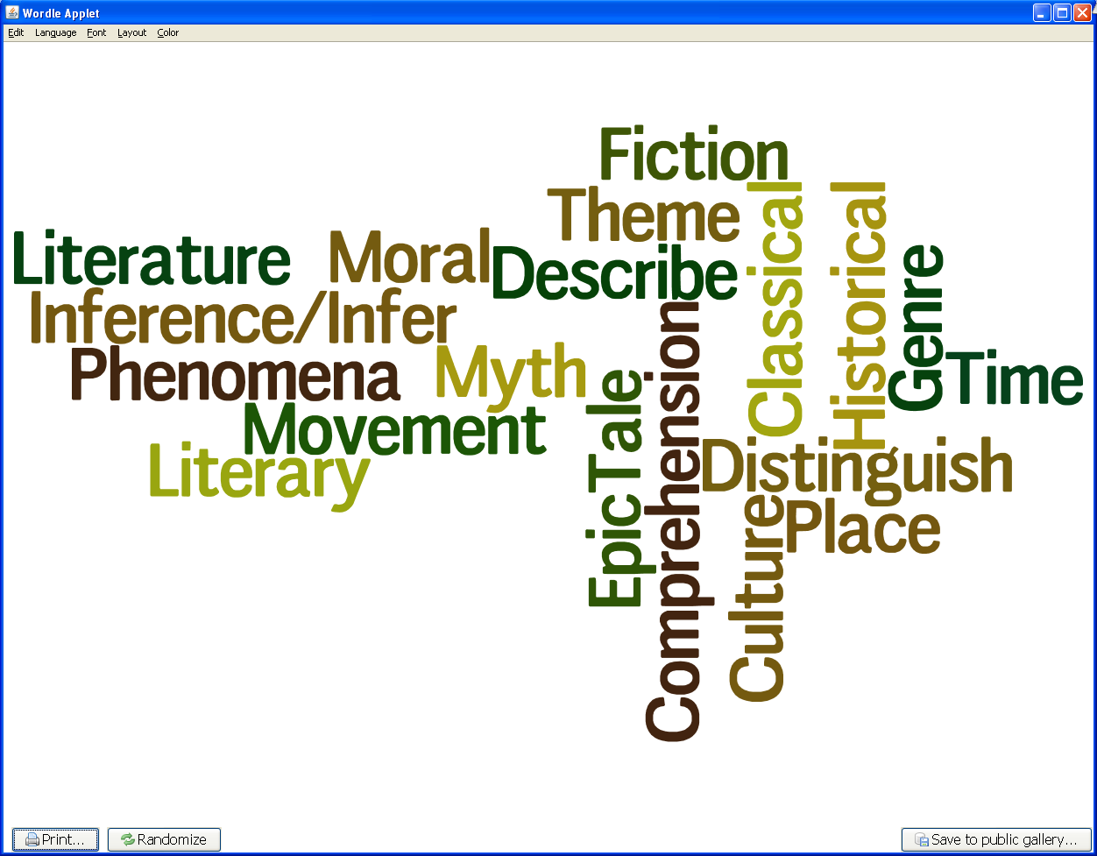

Reading/Comprehension of Literary Text/Poetry
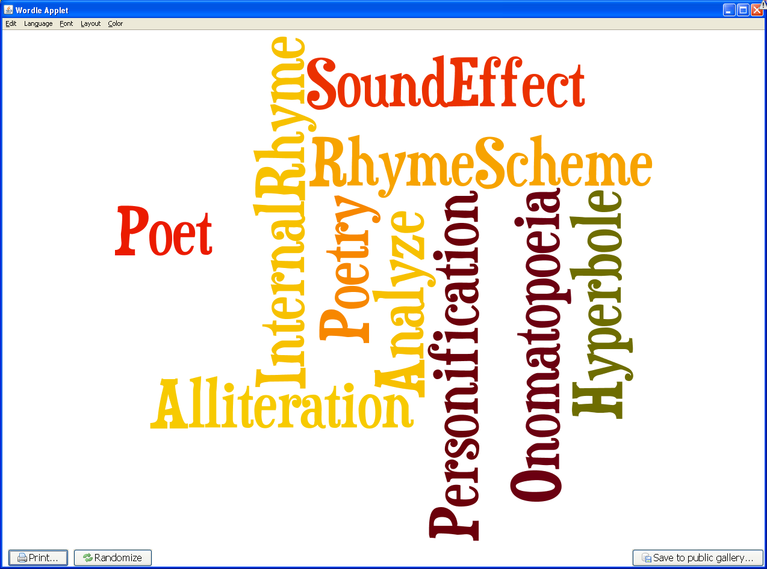

Reading/Comprehension of Literary Text/Sensory Language
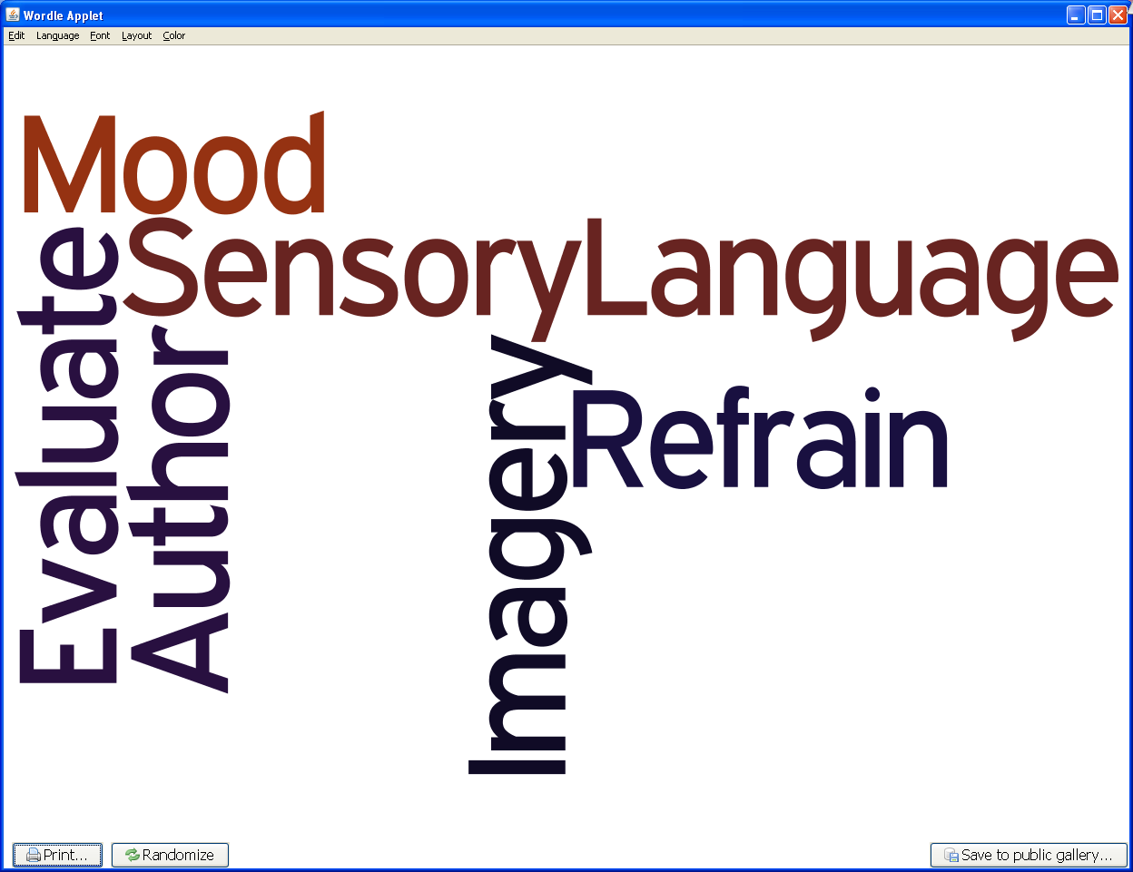

Reading/Comprehension of Text/Independent Reading

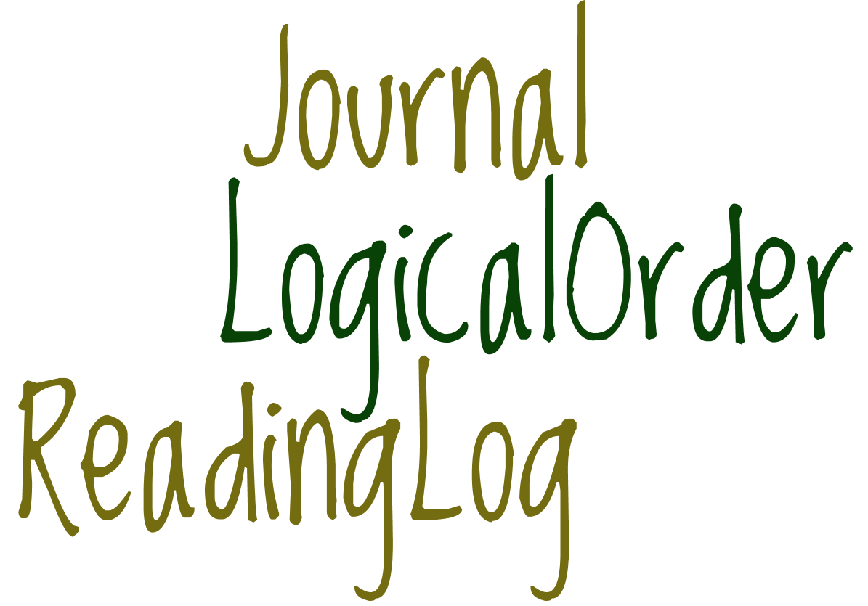

Reading/Comprehension of Literary Text/Fiction
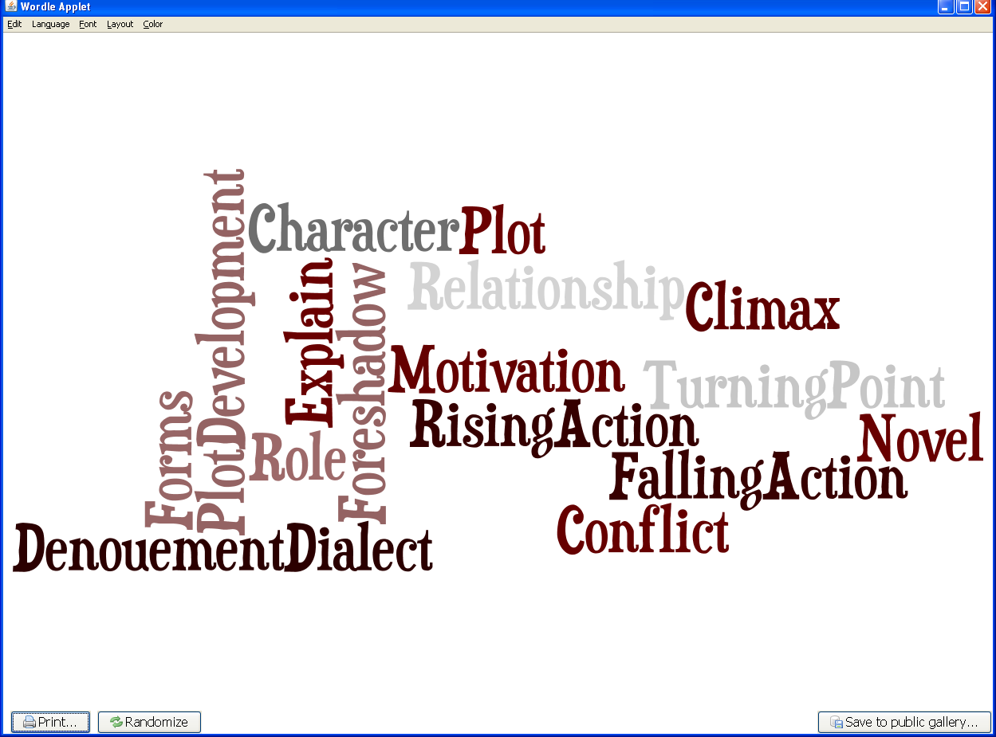

Reading/Comprehension of Literary Text/Literary Nonfiction
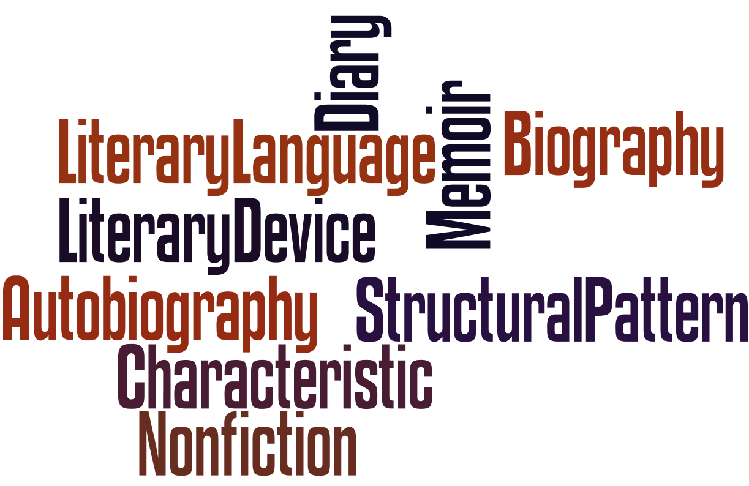
Reading/Comprehension of Informational Text/Expository Text
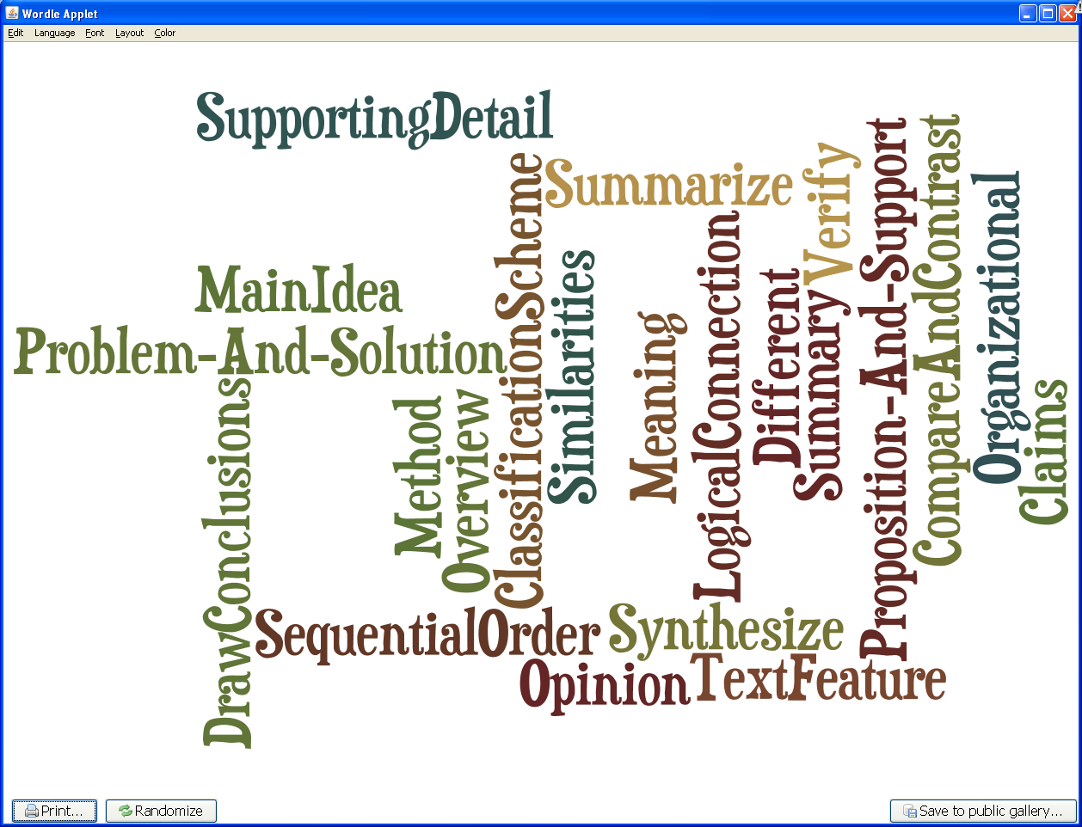

Reading/Comprehension of Informational Text/Persuasive Text
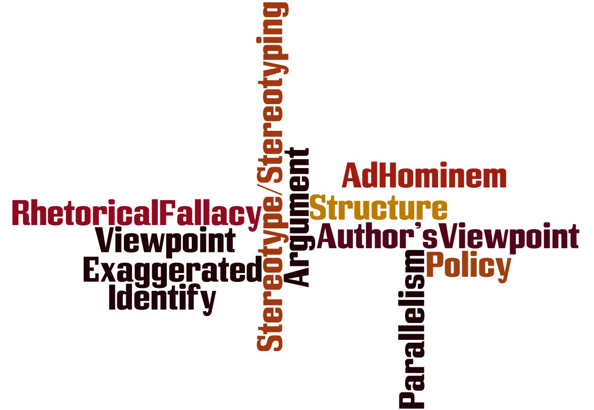

Reading/Comprehension of Informational Text/Culture and History
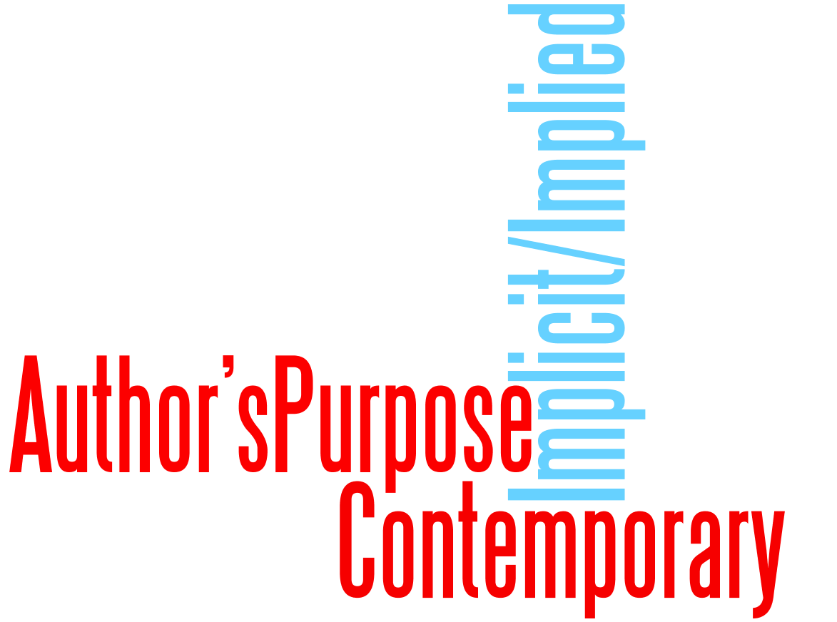
Reading/Comprehension of Informational Text/Procedural Texts
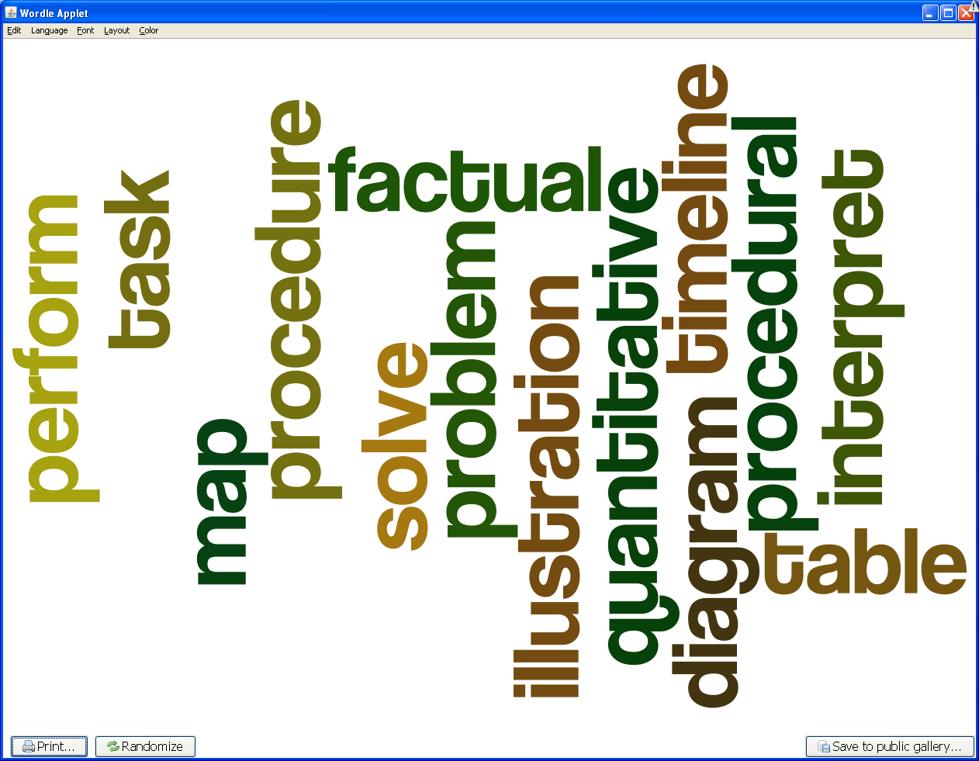
Reading/Media Literacy
