Mathematics Academic Vocabulary
Number, operation, and quantitative reasoning |  | Patterns, relationships, and algebraic thinking |  | Geometry and spatial reasoning
addition  algorithm  approximate  calculator  common denominator  common factor  compare  compatible  decimal  denominator  density  digit  dividend  division  divisor  equivalent  exponent  fraction  generate  hundredths  identify  improper fraction  integer  justify  mixed number  models/model  multiple  multiplication  non-negative number  number/ numerical | object  operation  order  order of operations  percent  place value  price  prime factor  problem  quantitative reasoning  quantity  rate  ratio  rational number  reasonableness/ reasonable  remainder  represent  round  simplify  situation  solve  speed  square  square number  square root  subtraction  tenths  thousandths  whole number  write | algebra  area  arithmetic  charts  composite number  concrete  constant  conversion  describe  equation  factor pairs  formula  formulate  graphic organizers  linear  lists  prime number  proportional  rate of change  rectangular prism  relate/related  relationship  scaling  sequence  symbol  table |  | angle  attribute  axis  circle  circumference  classify  complementary/ supplementary  cone  congruent  coordinate  coordinate grid  coordinate plane  cylinder  diameter  essential  figure  geometric  geometry  graph  grid  horizontal  locate  net  ordered pair | pair  parallel  perpendicular  points  polygon  prism  pyramid  quadrant  quadrilateral  radius  reflection  result  rotation  side  similarity  sketch  spatial reasoning  surface area  three-dimensional  transformation  translation  triangular  two-dimensional  vertical
Measurement |  | Probability and statistics |  | Underlying processes and mathematical tools
application  capacity  circumference  Celsius  connect  elapsed time  estimate  Fahrenheit  length  measure  BOLD high-frequency word in the TEKS | measurement  metric  perform  perimeter  shape  system of measurement  temperature  time  unit  volume  weight | bar graph  collect  complement  composite experiments  construct  data  diagram  display  experiment/ experimental  graphs  independent  interpreting  line graph  line plot | mean  median  mode  number pair  organize  prediction  present  probability  range  sample space  statistics  stem and leaf plot  tree diagram  Venn diagram | answer  apply  checking  communicate  conclusion  conjecture  develop  evaluate  example/ nonexample  explain  generalization  incorporate  logical reasoning  manipulative | mathematical  number sense  observation  pattern  problem-solving  process  properties  select  solution  strategy  technology  tool  validate  verify
Number, operation, and quantitative reasoning
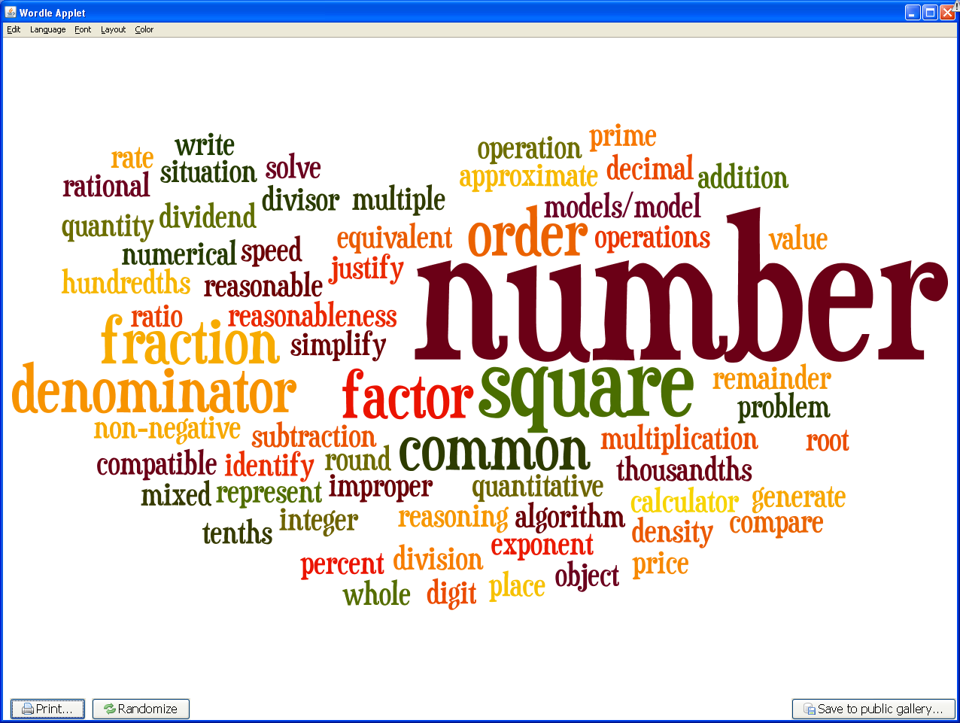
Patterns, relationships, and algebraic thinking
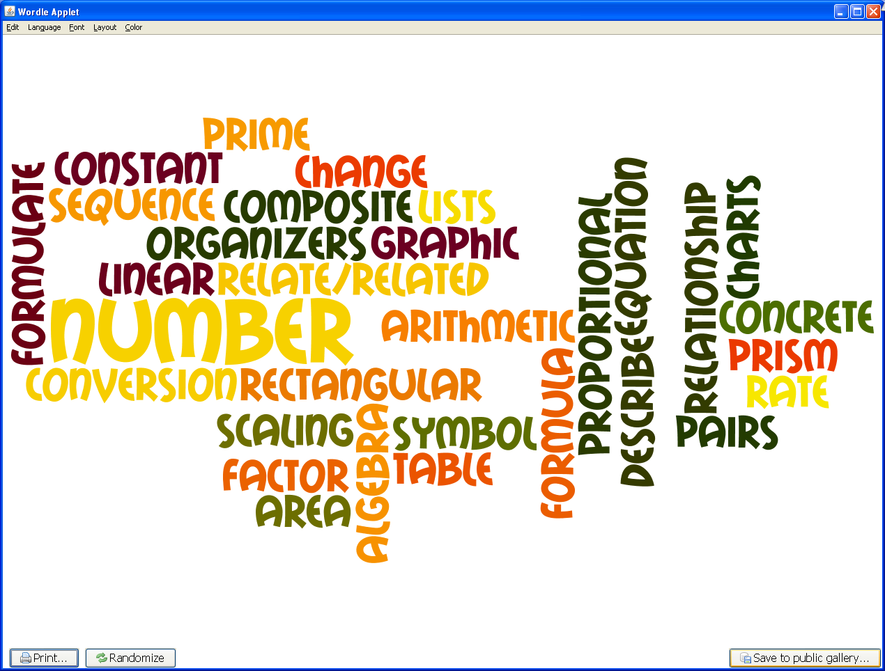
Geometry and spatial reasoning
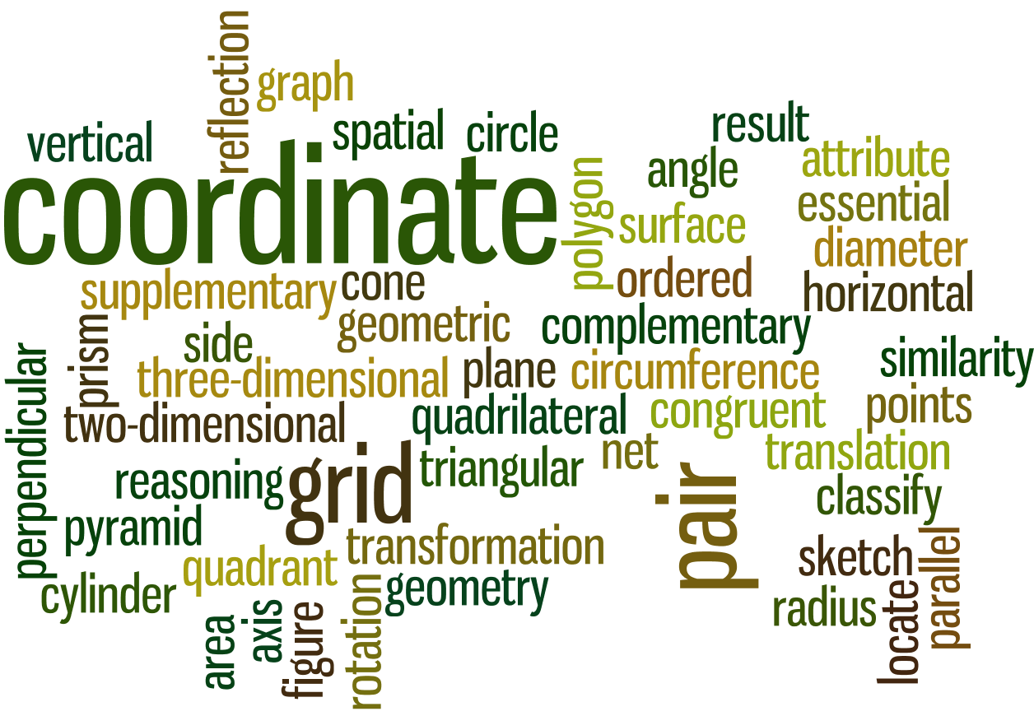
Measurement
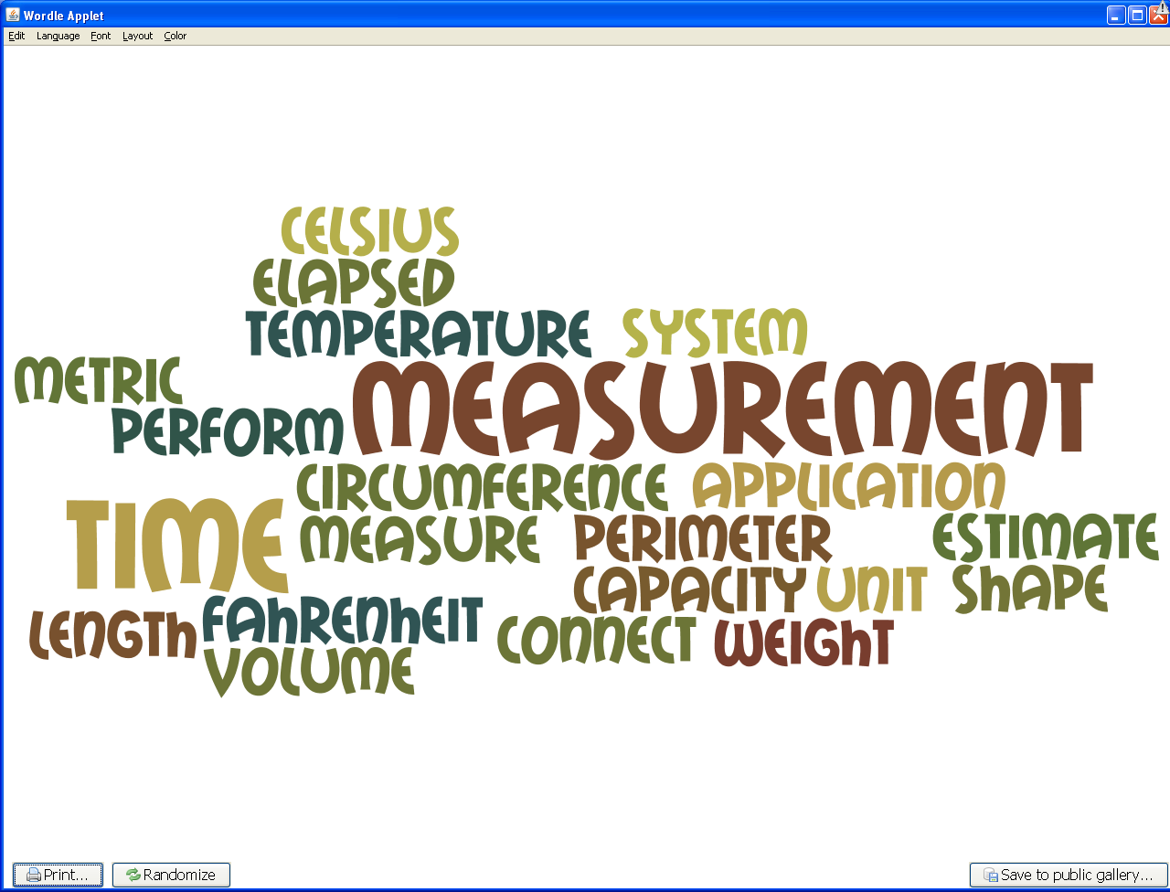
Probability and statistics
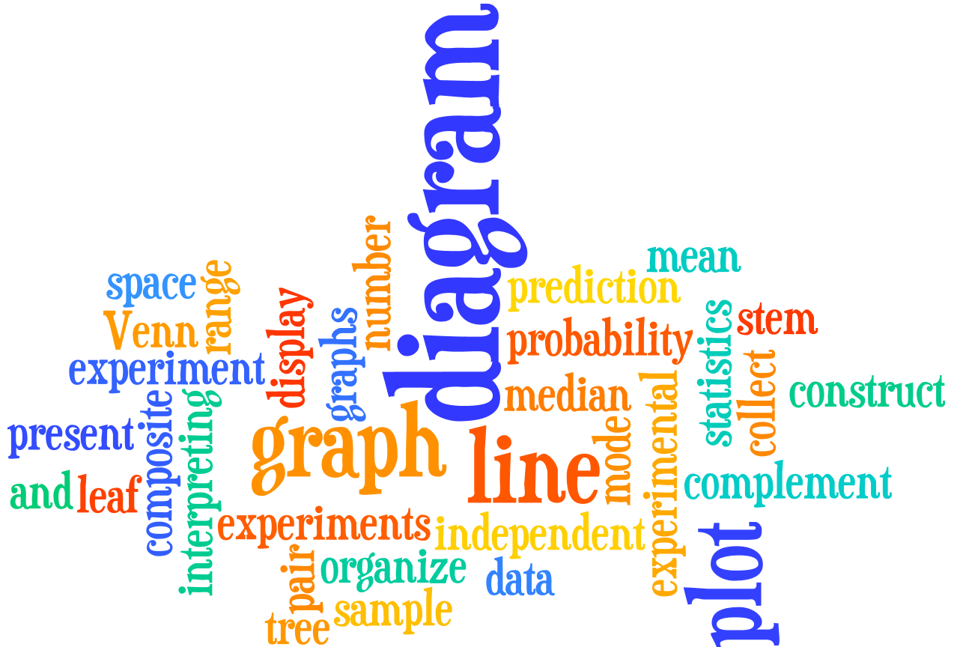
Underlying processes and mathematical tools
