ASK

CPQ

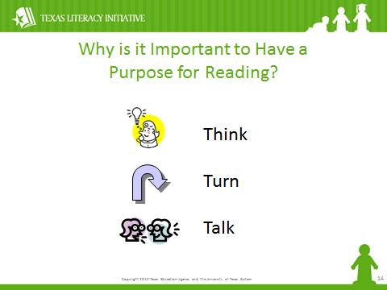

**Making Connections**

C:\Documents and Settings\ddycha\Local Settings\Temporary Internet Files\Content.IE5\1TTJYVJL\MCj03299300000[1].wmf

**Creating Mental Images**

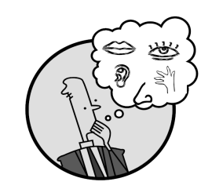

**Making Inferences &**

**Predictions**

C:\Documents and Settings\ddycha\Local Settings\Temporary Internet Files\Content.IE5\PICBQBTG\MCj02503920000[1].wmf

**Asking & Answering Quest** **ions**

C:\Documents and Settings\ddycha\Local Settings\Temporary Internet Files\Content.IE5\D3TFXU7L\MCj03841720000[1].wmfC:\Documents and Settings\ddycha\Local Settings\Temporary Internet Files\Content.IE5\D3TFXU7L\MCj03841720000[1].wmfC:\Documents and Settings\ddycha\Local Settings\Temporary Internet Files\Content.IE5\D3TFXU7L\MCj03841720000[1].wmf

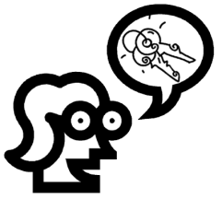**Determining Importance & Summarizing**

**Monitoring & Clarifying**

C:\Documents and Settings\ddycha\Local Settings\Temporary Internet Files\Content.IE5\PICBQBTG\MCj04242520000[1].wmf

ANSWER

 CPQ

Porter Literacy Line 