Teacher Guide for Determining Importance and Summarizing

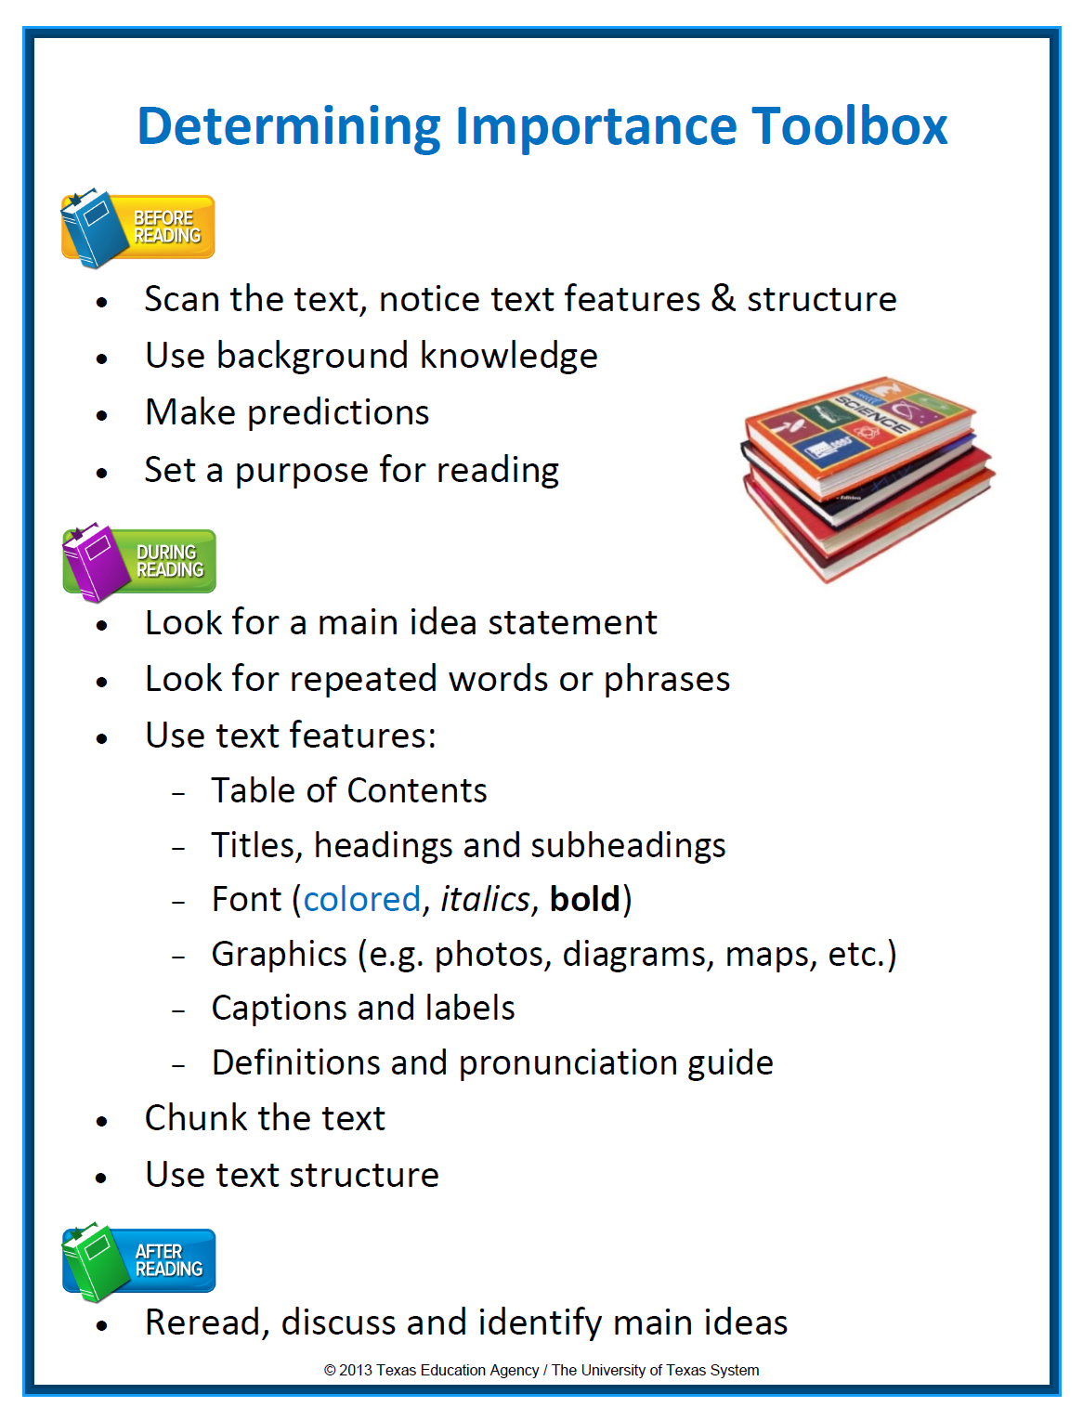
# 1 GOAL: For students to internalize knowledge about text structure and use it to enhance their reading comprehension and improve their writing organization, resulting in better STAAR scores.
Scan the Text, Notice Text Features & Structure
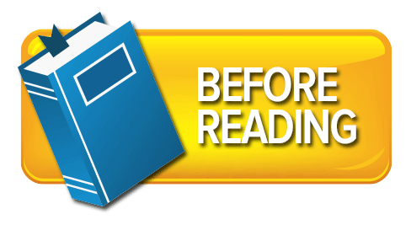
- What do I notice about the text?
- What text features have been included to support me as I read the text?
- What “grabs” my attention?
- What does the text appear to be about?

Use Background Knowledge and Make Predictions
Good readers:
- Make connections to background knowledge if the topic is familiar.
- Make connections to related topics and concepts if the topic is unfamiliar.
  - E.g. Spring thaw … ice cubes melting
- Make predictions about the text.

Set a Purpose for Reading
- Good readers identify a purpose for reading. –Teacher CPQ? or –Student CPQ?
- Rely on titles or headings.
- Review test questions.
- Consider predictions.
- What do I want to learn from reading this text?
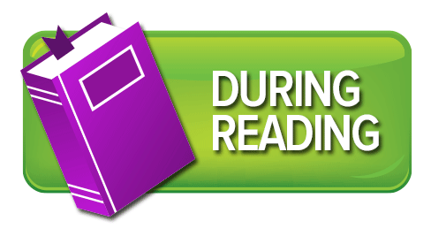
Look for a Main Idea Statement
- Main ideas can be directly stated in the text or inferred.
- “Baumann (1986) found that only about 15% of paragraphs in adult expository material have the topic sentence in the initial position. He also found that only 30% of the paragraphs have the main idea explicitly stated anywhere in the paragraph. These findings strongly suggest that we must teach students to overcome the lack of an explicitly stated main idea.”
- When students don’t encounter an explicit main idea in the first sentence, they form a guess about the main idea of the passage and then check later sentences against this guess. (Kissner, 2006, p. 42)
- When main ideas are implicit, readers rely on other “tools” to help them formulate and check their main idea inferences.

Look for Repeated Words or Phrases
- Important information is often repeated.
- Good readers look for repeated words or phrases that carry similar meaning.
- If authors are repeating ideas or concepts in various ways, then likely that information is important.

Use Text Features:
- Table of Contents
- Titles, headings and subheadings
- Font (colored, italics, bold)
- Graphics (e.g., photos, diagrams, maps, timelines, etc.)
- Captions and labels
- Definitions and pronunciation guide
- Highlight main ideas (titles, headings, subheadings, main idea statements)
- Highlight important details (bold, italicized print, colored font, pull quotes)
- Explain ideas (graphs, photographs, pictures)
- Provide additional information (sidebars, captions)
Chunk the Text
- “Readers who are unaware of text structure do not approach text with any particular plan of action. Consequently, they tend to retrieve information from the text in a seemingly random way. Students aware of text structure on the other hand, tend to “chunk” or organize the text as they read.” (Snow, 2002, p.40)

Use Text Structure
- Five Main Text Structures
  - Descriptive (Informational Text-Main Focus for DIS Part 1)
  - Sequential/Chronological
  - Cause and Effect
  - Compare and Contrast
  - Problem and Solution
- Descriptive texts are written to describe an object, person, place, event or idea.
- The topic is described by listing or explaining its features or characteristics, often examples are provided.
- Descriptive writing is filled with details; some details are interesting and some details are important. Just because a detail is interesting doesn’t make it most important.
- The main idea in descriptive text is may be implicitly stated.
- Creating mental images while reading descriptive text helps to more effectively identify the main idea.
- Specific characteristics or features are described or explained (size, shape, location, color, etc).
- Descriptive adjectives are used throughout the text.
- Details are provided to help the reader visualize the topic.
- Examples are often provided (for instance, such as, an example, to illustrate, to demonstrate).
- The topic word or a synonym for the topic is often repeated.

Descriptive Text Structure Guiding Questions to fill out Graphic Organizer
- Topic: What specific topic, person, idea, or thing is being described or explained? (One-two words.)
- Important Details: How is the topic being described or explained? (What is it, what does it look like, what does it do, what happens, etc.)
- Main Idea: What features or characteristics are important to remember or understand about the topic being described? (One sentence of less).
- Summary: What are the main ideas and important details that are necessary to include? How will you state them in your own words following the structure of the text? (As concisely as possible)
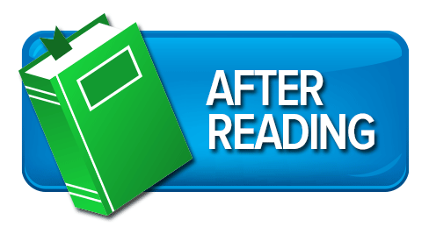
Reread, Discuss and Identify Main Ideas
- Reread to clarify and confirm the main idea.
- Discuss to consolidate understanding and remember the text better.

Summarizing: Model as many times and gradually move from a short passage/paragraph to longer texts
- “To summarize effectively, students need to recognize main ideas and key details, disregard unimportant or repetitive ideas, construct topic sentences, paraphrase, and collapse or combine lists or events into general statements.”
A summary should:
- Reflect the structure of the text.
- Include a topic sentence.
- Include the main ideas.
- Include important details.
- Be paraphrased and shorter than the original text.

