Writing/Writing Process |  |  | Writing/ Literary Texts |  | Writing/  Expository and Procedural Texts |  | Oral and Written Conventions/ Conventions
background reading  cause and effect  coherent  complex sentence  controlling idea  develop  discussion  draft  edit  enhance  feedback  genre  grammar  interview  personal interests  process  publish  purpose  revise  sequence of events  simple sentence  spelling  strategy  style  thesis  BOLD high-frequency word in the TEKS |  |  | dialogue  element  figurative language  focus  graphic  imaginative story  metaphor  meter  poem  point of view  sensory details  setting  similes  story  story line  write |  | closing/closure  concluding paragraph  conventions  convey  demonstrate understanding  details  essay  expository  fact  formal  guide  inconsistency  inform  information  introduction  key idea  letter  multimedia  paragraph  present  presentation  response  rhetorical device  salutation  sentence structure  sound  topic  transition |  | active voice  adjective  adverb  antecedent  appositive phrase  collective nouns  comparative adjective  compound sentence  conjunctive adverb  context  function  indefinite pronoun  irregular verb  modifier  parallel structure  participle |  | parts of speech  passive voice  perfect tense  phrase  predicate  preposition  prepositional phrase  progressive tense  relative pronoun  subject  subject-verb agreement  subordinate clause  subordinating conjunction  superlative adjective  tense  verb
 | Oral and Written Conventions/Handwriting, Capitalization, and Punctuation |  |  | Listening and Speaking/ Speaking |  | Listening and Speaking/ Listening |  | Research/ Gathering Sources |  | Research/ Synthesizing Information
 | abbreviation  acronym  brackets  capitalization  clause  colon  comma  composition  ellipses  emphasis  hyphen | initials  italics  legible  mechanics  organization  parentheses  punctuation  punctuation mark  quotation  semicolon  title |  | enunciation  eye contact  gesture |  | instructions  message  nonverbal/ verbal  perspective |  | bibliography  chart  cite/citation  data  differentiate  electronic  online  paraphrase  periodical  plagiarism  primary source  record  reference  research plan  resource  secondary source  technology  visual |  | relevant/irrelevant  reliable/reliability  source  valid/validity
 | Writing (Personal) |  |  | Oral and Written Conventions/ Spelling |  | Writing/ Persuasive Texts |  | Research/ Research Plan |  | Research/ Organizing and Presenting Ideas
 | action  communicate  consequence  personal narrative  BOLD high-frequency word in the TEKS |  |  | consonant  Greek suffix  Latin suffix  spelling pattern  suffix  vowel  word processing |  | alternative/ alternate  audience  consider  counter-argument  establish  persuasive  position |  | brainstorm  consult  decide  open-ended question  research  research question |  | compile  conclusion  documentation  evidence  findings  format  topic sentence
Writing/Writing Process

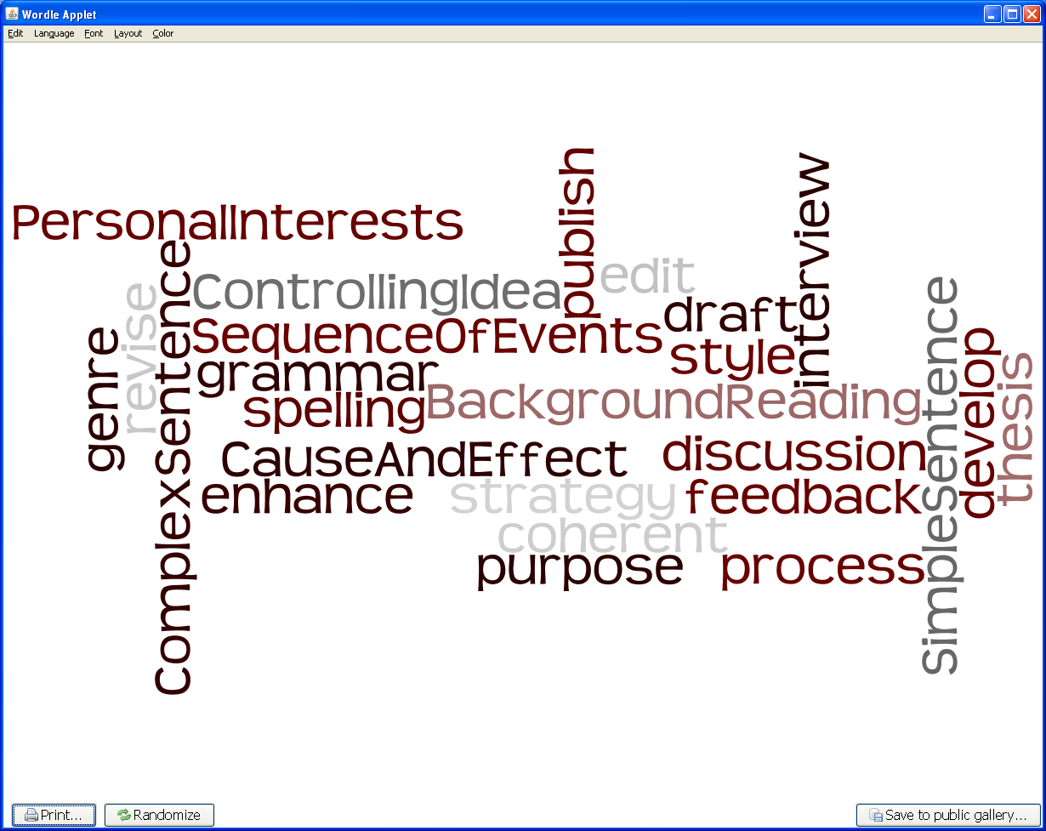
Writing/ Literary Texts

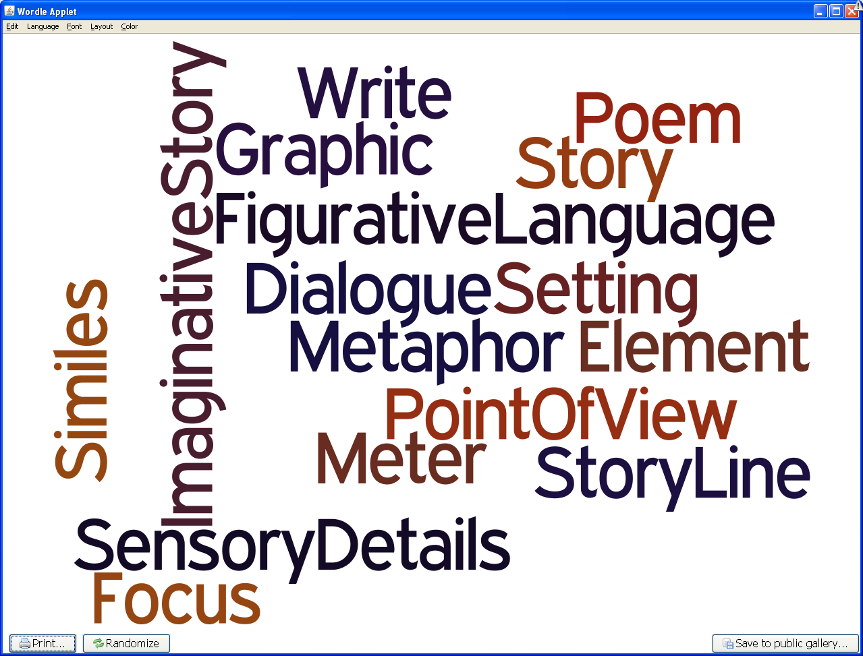
Writing/
Expository and Procedural Texts
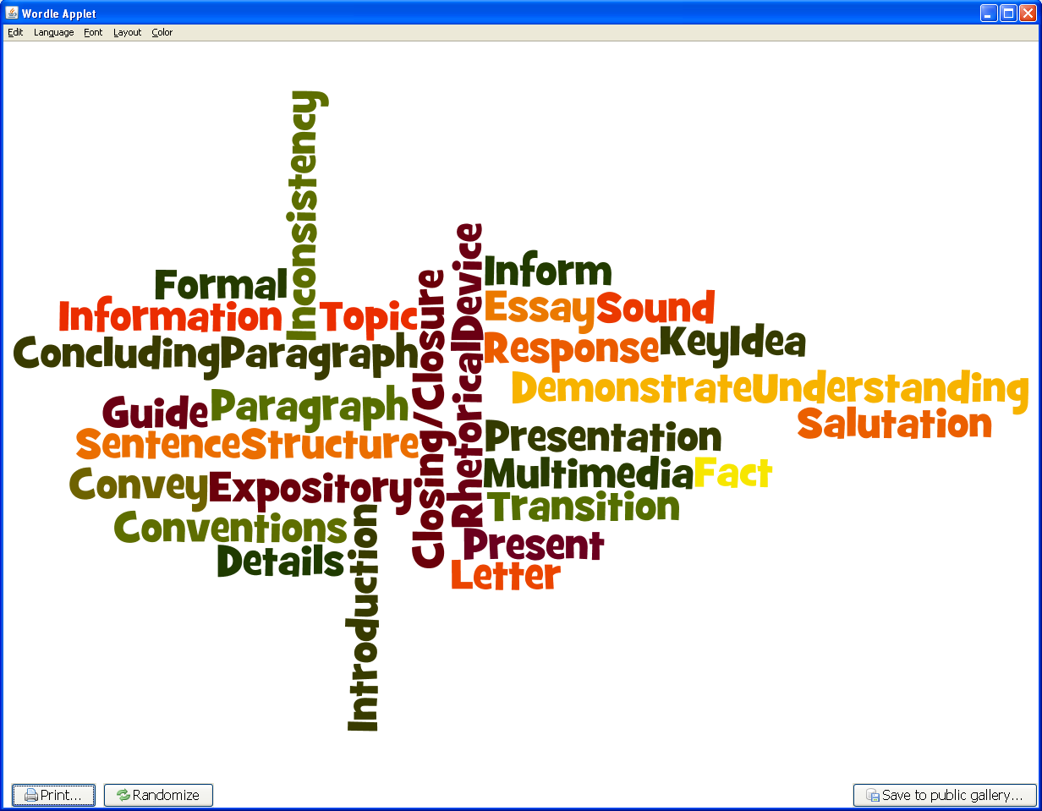

Oral and Written Conventions/ Conventions
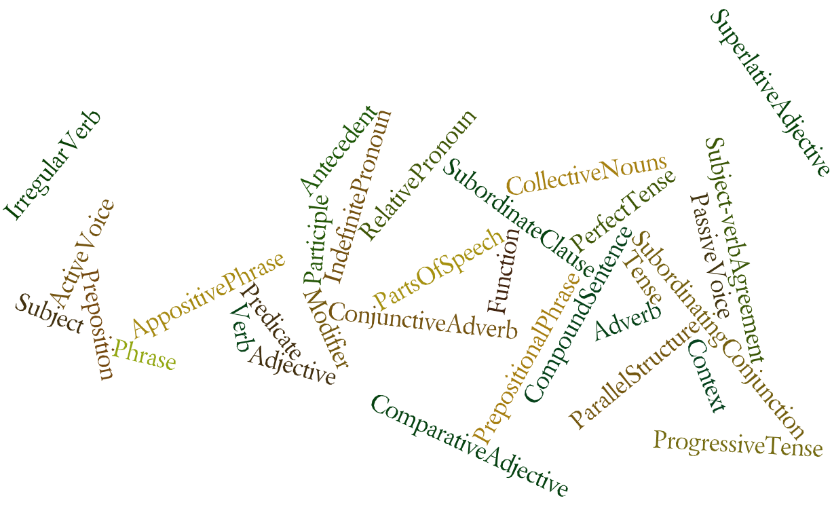
Oral and Written Conventions/Handwriting, Capitalization, and Punctuation
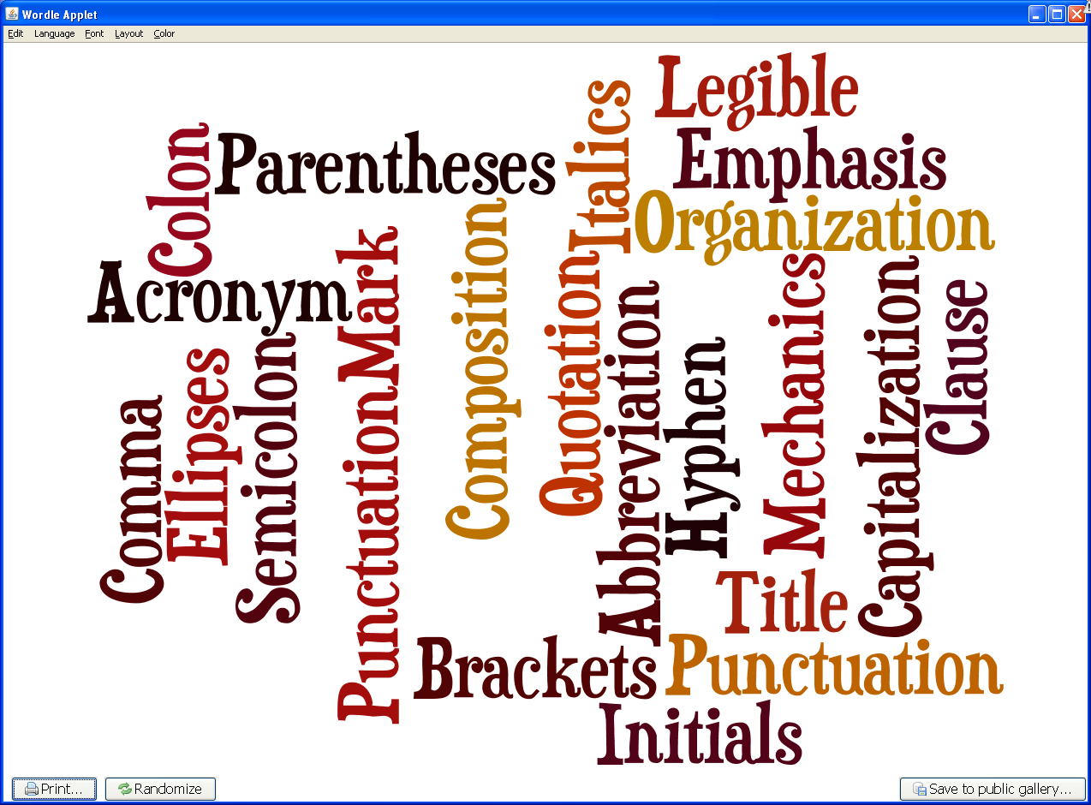
Listening and Speaking/ Speaking
Listening and Speaking/ Listening
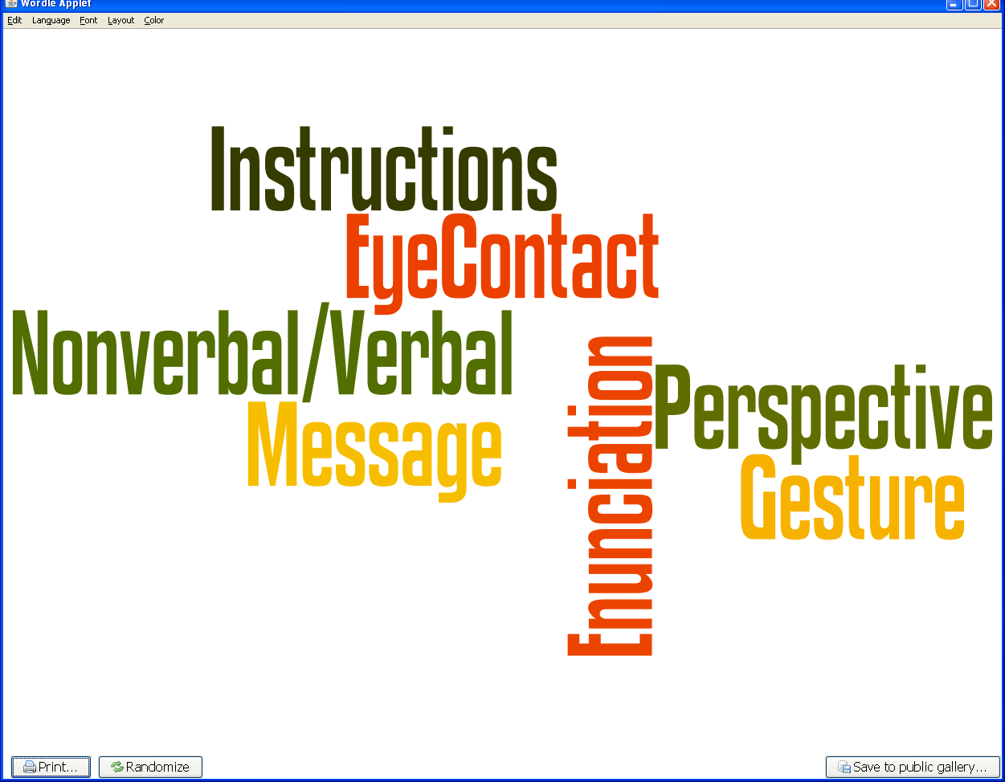
Research/ Gathering Sources
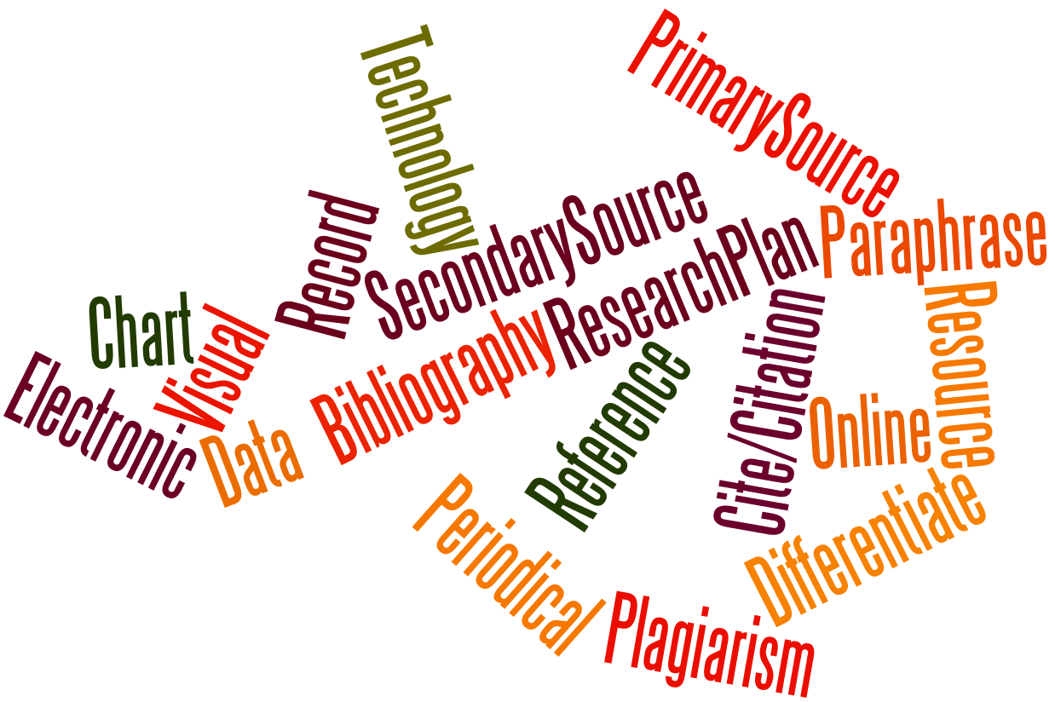
Research/ Synthesizing Information
Writing (Personal)

Oral and Written Conventions/ Spelling
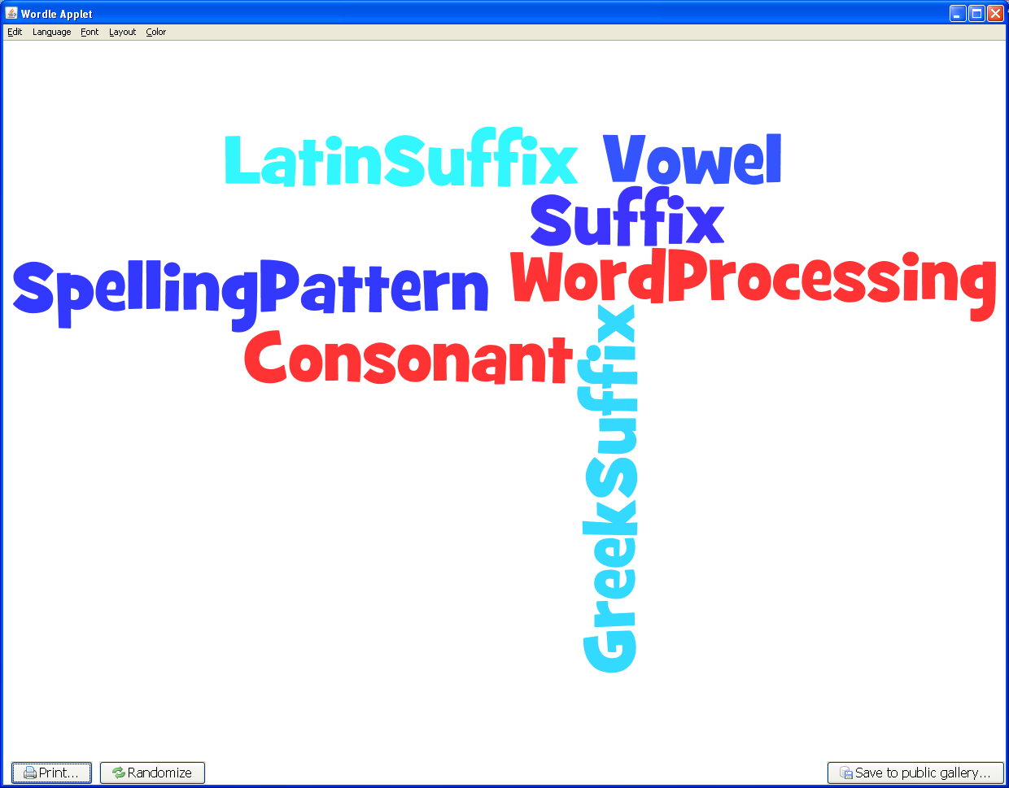
Writing/ Persuasive Texts
Research/ Research Plan
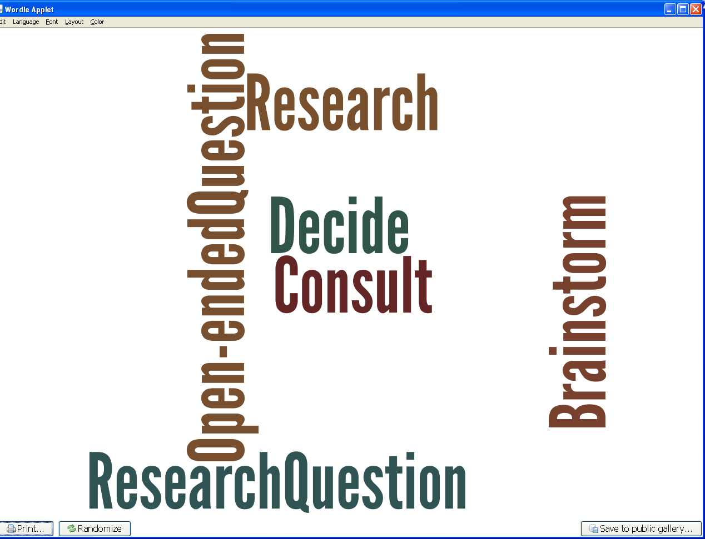
Research/ Organizing and Presenting Ideas
